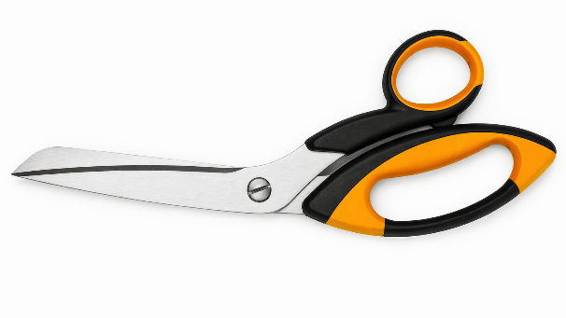
Sturdy universal tailor’s shears for cutting glass, carbon and Aramid fibres with 2 micro-serrated blades.

This product is used in various manufacturing processes of parts made of polymer composite materials.

TECHNICAL DATA | VALUE
Blade length | 120 mm
Scissors length | 250 mm
Scissors weight | 230 g

NOTES

Please contact us for ordering scissors of different size.

